


Data Compliance Test (DCT)
Test Cases for
Investigation Record

<HCP Name>

Table of Contents
1 Testing Instructions to HCPs 3
1.1 Self-Service Testing Phase 3
1.2 Final Testing Phase 3
1.3 Preparation DCT Test Report 4
2 Test Case Details 5
INVR-001 5
INVR-002 8
3 Appendix – Sample Messages 11
4 Appendix – Testing HCP and HCRs Information 13
5 Appendix – Sample Results in eHR Viewer (EVE) 13
6 Appendix – Actual Data Values (Sample) 16

Testing Instructions to HCPs

Self-Service Testing Phase
- After development of the data upload programmes, you can use the Self-Service test accounts and test HCRs provided by eHealth for connection to the eHealth testing environment and proceed with the self-service testing.
- You can proceed with the Self-service test at your own pace by following this Self-Service Testing Guide and using the test cases provided in section 2.
- You can verify the correctness and completeness of the data upload by:
- checking the interface files / messages generated in your system against the sample expected results of interface files /messages for all test cases as provided;
- checking the results on eHR Viewer (EVE) by logging into the testing eHealth with the provided test account; and
- checking the upload status through Process Summary and Exception Report in eHR Inbox by logging into the testing eHealth.
- For data fields requiring eHR Codex values, you can refer the Code Sets provided with the Self-Service Kit.
- For details of technical requirements of the data interface files, please refer to the ‘Developer Quick Guide for Investigation Report Upload to eHealth.docx’.
- You are required to perform the test cases that are relevant to the data compliance level (Level 1) supported by your clinic.
- You are required to perform the first batch of data upload by Data Materialization (DM) mode. DM mode is denoted in the interface by a fixed value BL-M in HL7 OBX.4
- You should use Incremental Load (INC) mode for the second batch of data upload to update the previously uploaded records. INC mode is denoted in the interface by a fixed value BL in HL7 OBX.4.
- Since the DM mode would replace the corresponding records previously uploaded to eHealth, you may repeat your testing unlimited number of times by uploading the first batch by DM mode.
- It should be noted that the data field “Record Key” should be unique for each investigation report record.
- When all required test cases can be completed smoothly and correctly in this phase, you can proceed to the Final Testing Phase and submit production environment setup form to eHR DCT Support for preparation.

Final Testing Phase
- You can start the Final Testing Phase once all test cases in the Self-Service Testing phase are passed.
- You should start Final Test by executing the test cases provided in section 2 with Final Testing HCRs provided by eHR DCT Support.
- You can verify the correctness and completeness of testing results by checking results in eHR Viewer (EVE) and the upload status through Process Summary and Exception Report in eHR Inbox.
- For Investigation Report DCT test cases, there are TWO batches of data files / transactions to be uploaded to the testing eHealth. The required records must be correctly uploaded from these 2 consecutive batches respectively.
- The Final Test will be considered PASSED if all the following criteria are met:
- The TWO batches of test data files are uploaded consecutively in the correct sequence. The second batch of data files/transactions must be submitted after completion of processing of the first batch by eHealth
- No additional data files / transactions are uploaded in between or after the uploads of the above two batches of data files / transactions to amend any records.
- No exception records are reported from the uploads.
- No manual interventions have been made to the data files / transactions.
- If the Final Test failed, you can re-attempt the Self-Service Test and Final Test until a successful run can be completed.

Preparation DCT Test Report
- Once you have successfully passed the Final Test based on the above criteria, you should complete this document by attaching the below items to this document at the appropriate space provided:
  - Actual data files uploaded
  - Screen-shot of each test case
- You are required to submit this completed ‘DCT Test Cases’ document to eHR DCT Support for further processing. eHR DCT Support will provide feedback within 10 working days.

Test Case Details
1 | Test Case ID | INVR-001
 | Function Description | HCP has received the sharing consents from testing HCRs, then perform first data upload of HCRs’ clinical records to eHealth by DM Mode for Level 1 data.
 | Subsequent case of | N/A
 | Testing Assumption | - HCR1-HCR4 have already given sharing to sharing consent to the HCP.  - The EMR system (EMRS) will upload Batch 1 data files to eHealth with all investigation report records of <HCR1> - <HCR4> created by DM mode.
 | Test Actions | HCP creates below investigation report records in EMR system:
 | Test Actions | 1a | Case scenario: Input new Pulmonary function test report for <HCR1> in the EMRS for PDF report generation as follows:  - Investigation report reference date = 01-Jun-2023 10:00:00  - Investigation report title = Pulmonary function test  - Investigation report highlight = Respiratory  == Actual data values (Refer to “Appendix - Actual Data Values (Sample)” for details)  Expected data contents for Level 1 interface record:  - Investigation report reference date = 01-Jun-2023 10:00:00  - Report entity identifier = 100198  - Investigation report title = Pulmonary function test  - Investigation report highlight = Respiratory  - File Indicator = 1  - File name = [follow naming standards as specified in General Guide]  - Generated PDF report with the above data and file name
 | Test Actions | 1b | Case scenario: Input new Echocardiogram report for <HCR2> in the EMRS for PDF report generation as follows:  - Investigation report reference date = 01-Jul-2023 10:00:00  - Investigation report title = Echocardiogram  - Investigation report highlight = Cardiac  - Investigation report remark = Echo after CABG  == Actual data values (Refer to “Appendix - Actual Data Values (Sample)” for details)  Expected data contents for Level 1 interface record:  - Investigation report reference date = 01-Jul-2023 10:00:00  - Report entity identifier = 100285  - Investigation report title = Echocardiogram  - Investigation report highlight = Cardiac  - Investigation report remark = Echo after CABG  - File Indicator = 1  - File name = [follow naming standards as specified in General Guide]  - Generated PDF report with the above data and file name
 | Test Actions | 1c | Case scenario: (Only applicable for Level 1 data upload without PDF report)  Input new Treadmill report for <HCR3> in EMRS for Text report generation as follows:  - Investigation report reference date = 01-Aug-2023 10:00:00  - Investigation report title = Treadmill report  == Actual data values (Refer to “Appendix - Actual Data Values (Sample)” for details)  Expected data contents for Level 1 interface record:  - Investigation report reference date = 01-Aug-2023 10:00:00  - Report entity identifier = 100303  - Investigation report title = Treadmill report  - Investigation report (Text) = <Text report with the above data>  - File Indicator = 0  - File name = null  - No PDF report generated
 | Test Actions | 1d | Case scenario: (Only applicable for Level 1 data upload without PDF report)  Input new Echocardiogram report for <HCR4> in EMRS for Text report generation as follows:  - Investigation report reference date = 01-Sep-2023 10:00:00  - Investigation report title = Echocardiogram  - Investigation report highlight = Cardiac  - Investigation report remark = Echo after CABG  == Actual data values (Refer to “Appendix - Actual Data Values (Sample)” for details)  Expected data contents for Level 1 interface record:  - Investigation report reference date = 01-Sep-2023 10:00:00  - Report entity identifier = 100285  - Investigation report title = Echocardiogram  - Investigation report highlight = Cardiac  - Investigation report remark = Echo after CABG  - Investigation report (Text) = <Text report with the above data>  - File Indicator = 0  - File name = null  - No PDF report generated
 | Expected EMR System Behavior | - HCP’s EMR system will upload Batch 1 data files with all investigation report as below scenarios:  - Both ‘PDF’ and ‘TXT’ test cases provided: 1a-1d (Level 1 data) by DM mode.  - Only ‘PDF’ test cases provided: 1a-1b (Level 1 data) by DM mode.  - Only ‘TXT’ test cases provided: 1c-1d (Level 1 data) by DM mode.  - Batch 1 data files should include below files: <samples>  - Participant List (PL)  - Data File (DF)  - HL7 message with signature  - Zip File (embedded PL, DFs and HL7 message files)  - Zip Control File (contains the filenames of PL, DFs and HL7 message)  - EMR system uploads Batch 1 data files (‘Zip File’ and ‘Zip Control File') to eHealth.  - HCP verifies the data upload status by reviewing the 'Process Summary Report' and 'Exception Report' in eHR Inbox.  - HCP verifies the completeness and correctness of data uploaded in eHR Viewer.
 | Results Verification | - HCP verifies the interface file contents and check if the uploaded records can be properly viewed in eHR Viewer (EVE). HCP must also review if the data batches uploaded can be processed successfully or rejected through ‘Process Summary’, ‘Exception Report’ and ‘Re-grade Report’ in eHR Inbox.
 | Actual Result  (Screenshot / Attachment) | Data Files Uploaded:  <Attached the Zip file and Control file; password to unzip the file>
 | Actual Result  (Screenshot / Attachment) | Attachment/Screenshot:  <Attached the screen shots of records uploaded in eHR Viewers>
 | Remark | <State your reasons/ justification for exemption with case number>
 | Testing Date | <Provided by HCP>
 | Verified By | <Provided by HCP>

2 | Test Case ID | INVR-002
 | Function Description | There are subsequent changes in HCRs’ clinical records uploaded in Batch 1. HCP uploads incremental changes to eHealth by INC Mode for Level 1 data.
 | Subsequent case of | INVR-001
 | Testing Assumption | - HCP has already verified that Batch 1 data have been processed successfully with correct test results.
 | Test Actions | HCP updates investigation report records from Batch 1 in EMR system (EMRS) as follows:
 | Test Actions | 2a | Case scenario: Input new Echocardiogram report for <HCR1> in EMRS for PDF report generation as follows:  - Investigation report reference date = 10-Jun-2023 10:00:00  - Investigation report title = Echocardiogram  - Investigation report highlight = Cardiac  - Investigation report remark = Echo after CABG  == Actual data values (Refer to “Appendix - Actual Data Values (Sample)” for details)  Expected data contents for Level 1 interface record:  - Investigation report reference date = 10-Jun-2023 10:00:00  - Report entity identifier = 100285  - Investigation report title = Echocardiogram  - Investigation report highlight = Cardiac  - Investigation report remark = Echo after CABG  - File Indicator = 1  - File name = [follow naming standards as specified in General Guide]  - Generated PDF report with the above data and file name
 | Test Actions | 2b | Case scenario: Update [Investigation report identifier], [Investigation report title], [Investigation report highlight] & [Investigation report remark] of investigation report record in 1(a) for <HCR1> in the EMRS as follows:  - Investigation report identifier = 100285  - Investigation report title = Echocardiogram  - Investigation report highlight = Blank  - Investigation report remark = Echo after CABG for UPDATE  == Actual data values (Refer to “Appendix - Actual Data Values (Sample)” for details)  Expected data contents for Level 1 interface record:  - Investigation report reference date = 01-Jun-2023 10:00:00  - Report entity identifier = 100285  - Investigation report title = Echocardiogram  - Investigation report highlight = Blank  - Investigation report remark = Echo after CABG for UPDATE  - File Indicator = 1  - File name = [follow naming standards as specified in General Guide]  - Generated PDF report with the above data and file name
 | Test Actions | 2c | Case scenario: Delete investigation report record in 1(b) for <HCR2> in the EMRS  == Actual data values (Refer to “Appendix - Actual Data Values (Sample)” for details)  Expected data contents for Level 1 interface record:  - Batch 2 Data file will contain 1 Delete transaction for record 1(b)
 | Test Actions | 2d | Case scenario: (Only applicable for Level 1 data upload without PDF report)  Input new Echocardiogram report for <HCR3> in EMRS for Text report generation as follows:  - Investigation report reference date = 10-Aug-2023 10:00:00  - Investigation report title = Echocardiogram  - Investigation report highlight = Cardiac  - Investigation report remark = Echo after CABG  == Actual data values (Refer to “Appendix - Actual Data Values (Sample)” for details)  Expected data contents for Level 1 interface record:  - Investigation report reference date = 10-Aug-2023 10:00:00  - Report entity identifier = 100285  - Investigation report title = Echocardiogram  - Investigation report highlight = Cardiac  - Investigation report remark = Echo after CABG  - Investigation report (Text) = <Text report with the above data>  - File Indicator = 0  - File name = null  - No PDF report generated
 | Test Actions | 2e | Case scenario: (Only applicable for Level 1 data upload without PDF report)  Update [Investigation report remark] of investigation report record in 1(c) for <HCR3> in the EMRS as follows:  - Investigation report remark = DCT test case for UPDATE  == Actual data values (Refer to “Appendix - Actual Data Values (Sample)” for details)  Expected data contents for Level 1 interface record:  - Investigation report reference date = 01-Aug-2023 10:00:00  - Report entity identifier = 100303  - Investigation report title = Treadmill report  - Investigation report remark = DCT test case for UPDATE  - Investigation report (Text) = <Text report with the above data>  - File Indicator = 0  - File name = null  - No PDF report generated
 | Test Actions | 2f | Case scenario: Delete investigation report record in 1(d) for <HCR4> in the EMRS  == Actual data values (Refer to “Appendix - Actual Data Values (Sample)” for details)  Expected data contents for Level 1 interface record:  - Batch 2 Data file will contain 1 Delete transaction for record 1(d)
 | Expected EMR System Behavior | - HCP’s EMR system will upload Batch 2 data files with all investigation report as below scenarios:  - Both ‘PDF’ and ‘TXT’ test cases provided: 2a-2f (Level 1 data) by INC mode.  - Only ‘PDF’ test cases provided: 2a-2c (Level 1 data) by INC mode.  - Only ‘TXT’ test cases provided: 2d-2f (Level 1 data) by INC mode.  - Batch 2 data files should include below files: <samples>  - Participant List (PL)  - Data Files (DFs)  - HL7 message with signature  - Zip File (embedded PL, DFs and HL7 message files)  - Zip Control File (contains the filenames of PL, DFs and HL7 message)  - EMR system uploads Batch 2 data files (‘Zip File’ and ‘Zip Control File') to eHealth.  - HCP verifies the data upload status by reviewing the 'Process Summary Report' and 'Exception Report' in eHR Inbox.  - HCP verifies the completeness and correctness of data uploaded in eHR Viewer.
 | Results Verification | - HCP verifies the interface file contents and check if the uploaded records can be properly viewed in eHR Viewer (EVE). HCP must also review if the data batches uploaded can be processed successfully or rejected through ‘Process Summary’, ‘Exception Report’ and ‘Re-grade Report’ in eHR Inbox.
 | Actual Result  (Screenshot / Attachment) | Data Files Uploaded:  <Attached the Zip file and Control file; password to unzip the file>
 | Actual Result  (Screenshot / Attachment) | Attachment/Screenshot:  <Attached the screen shots of records uploaded in eHR Viewers>
 | Remark | <State your reasons/ justification for exemption with case number>
 | Testing Date | <Provided by HCP>
 | Verified By | <Provided by HCP>

Appendix – Sample Messages
Test Case ID | Step No. | File Type | Bulk Load Format | SOAP Format  (by LAAM)
INVR-001 | [DM]  [PDF report]  1a – 1b | Participant List (PL)
INVR-001 | [DM]  [PDF report]  1a – 1b | Data File (DF)
INVR-001 | [DM]  [PDF report]  1a – 1b | HL7 Message
INVR-001 | [DM]  [PDF report]  1a – 1b | Zip File | (Password: Abcd1234)
INVR-001 | [DM]  [PDF report]  1a – 1b | Control File
INVR-001 | [DM]  [Text report]  1c – 1d | Participant List (PL)
INVR-001 | [DM]  [Text report]  1c – 1d | Data File (DF)
INVR-001 | [DM]  [Text report]  1c – 1d | HL7 Message
INVR-001 | [DM]  [Text report]  1c – 1d | Zip File | (Password: Abcd1234)
INVR-001 | [DM]  [Text report]  1c – 1d | Control File
INVR-002 | [INC]  [PDF report]  2a – 2c | Participant List (PL)
INVR-002 | [INC]  [PDF report]  2a – 2c | Data File (DF)
INVR-002 | [INC]  [PDF report]  2a – 2c | HL7 Message
INVR-002 | [INC]  [PDF report]  2a – 2c | Zip File | (Password: Abcd1234)
INVR-002 | [INC]  [PDF report]  2a – 2c | Control File
INVR-002 | [INC]  [Text report]  2d – 2f | Participant List (PL)
INVR-002 | [INC]  [Text report]  2d – 2f | Data File (DF)
INVR-002 | [INC]  [Text report]  2d – 2f | HL7 Message
INVR-002 | [INC]  [Text report]  2d – 2f | Zip File | (Password: Abcd1234)
INVR-002 | [INC]  [Text report]  2d – 2f | Control File

Appendix – Testing HCP and HCRs Information
Sample Message
Self-Service Testing | <Attach the testing HCRs excel file used>
Final Testing | <Attach the testing HCRs excel file used>
  - eHR DCT Support will provide other sets of testing HCRs for HCP to perform Self-Service testing and Final testing respectively.

Appendix – Sample Results in eHR Viewer (EVE)
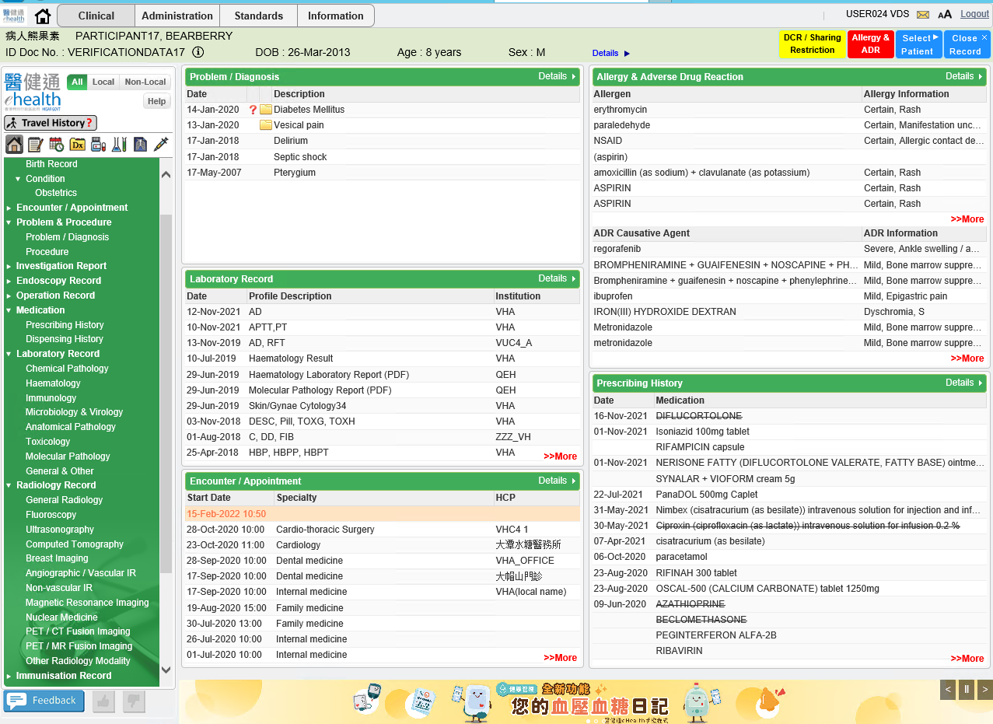
- After logging on the eHealth portal and searching the HCR, the clinical record of the HCR will be shown in below page.

- Click Tree node of Investigation Report to Document View
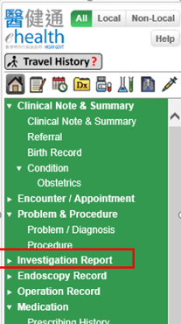

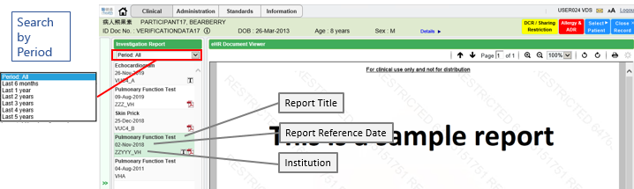
- User can filter the record by entering the ‘period’ in the left panel of Document View page. Report Title, Report Reference Date and Institution of each record can then be found on left panel.

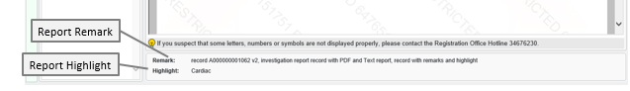
- Report Remark, Report Highlight can be found in the bottom panel of Document View page.

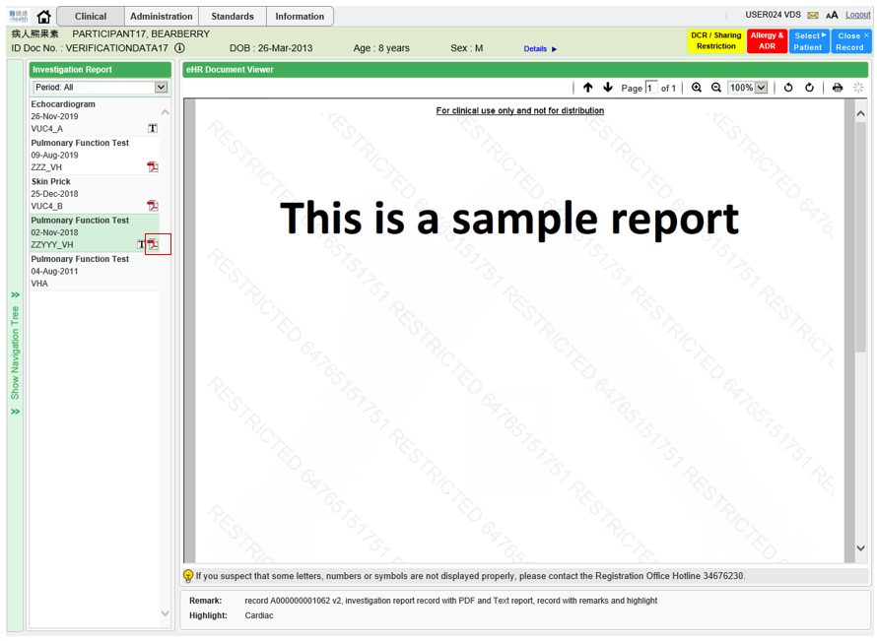
- Click PDF icon on the left panel record to show the PDF report.

- Click TEXT icon on the left panel record to show the text report.
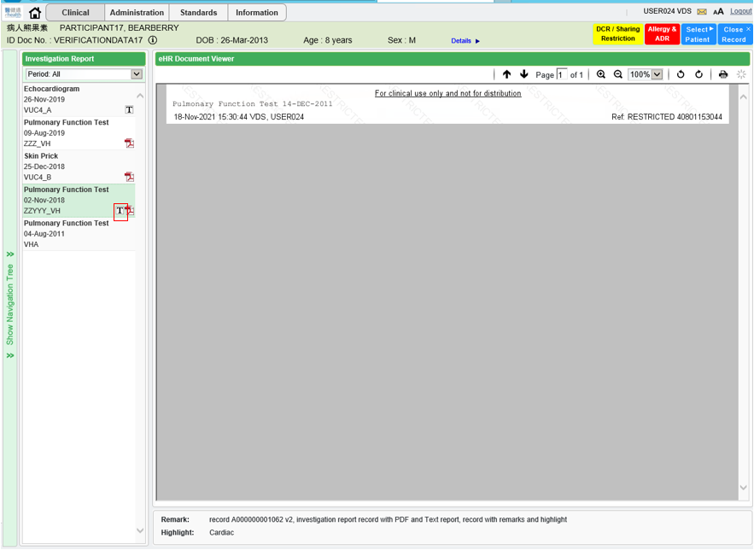

Appendix – Actual Data Values (Sample)

If the actual values entered are various from the test case, please provide actual values as below.
If the value is not inputted, please use [BLANK] to indicate that empty value is inputted intentionally.

